

PROJECT REPORT ON

FAKE REVIEWS IDENTIFICATION

Submitted in the partial fulfilment of the requirement for the award of degree of

# Master of Computer Applications

**COURSE CODE: CAP777**

# Submitted by:

**BHARTI (12108986)**

# SHASHI KUMAR (12107108)

**Submitted to: ADITI SHARMA (28529)**

**Acknowledgment**

The Project I had under the STAR COURSE – CAP777 (WEB DEVELOPMENT USING PHP) was a great chance for learning and professional development. Therefore, I consider myself as a very lucky individual as I was provided with an opportunity to be a part of it.

I express my deepest thanks to my course instructor Aditi sharma (Assistant Professor) SCA, LPU for allowing me to grab this opportunity. I choose this moment to acknowledge his contribution gratefully by giving necessary advices and guidance to make my internship a good learning experience.

**BHARTI (12108986)**

# SHASHI KUMAR (121071

|  |  |  |
| --- | --- | --- |
| Sr. No. | Description | Page No. |
| 1 | Introduction to the Project | 4 |
| 2 | Abstract | 5 |
| 3 | Purpose, Scope and Advantages of the Project | 6 |
| 4 | Modules of the Project | 7 |
| 5 | Software Requirements. | 8 |
| 6 | Working | 9 |
| 7 | Roles of individuals in the Project | 9 |
| 8 | User flow chart | 10 |
| 9 | Admin flow chart | 11 |
| 10 | Database | 12-16 |
| 11 | Interface design | 13-30 |
| 12 | Srs need | 31 |
| 13 | Other code snippets | 33- |
| 14 | Conclusion | 32 |
| 15 | Bibliography or References | 33 |

**INTRODUCTION**

# The Importance of Google Reviews | Google Business Reviews

The rapid growth of the Internet influenced many of our daily activities. One of the very rapid growth areas is ecommerce. Generally, e-commerce provide facility for customers to write reviews related with its service. The existence of these reviews can be used as a source of information. For examples, companies can use it to make design decisions of their products or services, while potential customers can use it to decide either to buy or to use a product. Unfortunately, the importance of the review is misused by certain parties who tried to create fake reviews, both aimed at raising the popularity or to discredit the product. This research aims to detect fake reviews for a product by using the text and rating property from a review. In short, the proposed system will measure the honesty value of a review, the trustiness value of the reviewers and the reliability value of a product. In some review websites some good reviews are added by the product company people itself in order to make in order to produce false positive product reviews. They give good reviews for many different products manufactured by their own firm. User will not be able to find out whether the review is genuine or fake. To find out fake review in the website this “FAKE REVIEW IDENTIFICATION” system is introduced. This system will find out fake reviews made by posting fake comments about a product. User will login to the system using his user id and password and will view various products and will give review about the product. To find out the review is fake or genuine, system search a user who gave same review on any products and admin can delete it.

**ABSTRACT**

In e-commerce, user reviews can play a significant role in determining the revenue of an organization. Online users rely on reviews before making decisions about any product and service. As such, the credibility of online reviews is crucial for businesses and can directly affect companies’ reputation and profitability. That is why some businesses are paying spammers to post fake reviews. These fake reviews exploit consumer purchasing decisions. Consequently, the techniques for detecting fake reviews have extensively been explored in the past twelve years. However, there still lacks a survey that can analyses and summaries the existing approaches. To bridge up the issue, this survey paper details the task of fake review detection, summing up the existing datasets and their collection methods. It analyses the existing feature extraction techniques. It also summarizes and analyses the existing techniques critically to identify gaps based on two groups: traditional statistical machine learning and deep learning methods. Further, we conduct a benchmark study to investigate the performance of different neural network models and transformers that have not been used for fake review detection yet. The experimental results on two benchmark datasets show that Roberta performs about 7% better than the state-of-the-art methods in a mixed domain for the deception dataset with the highest accuracy of 91.2%, which can be used as a baseline for future studies. Finally, we highlight the current gaps in this research area and the possible future directions. Product reviews are now widely used by individuals for making their decisions. However, due to the purpose of profit, reviewers’ game the system by posting fake reviews for promoting or demoting the target products. In the past few years, fake review detection has attracted significant attention from both the industrial organizations and academic communities. However, the issue remains to be a challenging problem due to lacking of labelling materials for supervised learning and evaluation. Current works made many attempts to address this problem from the angles of reviewer and review.

# PURPOSE OF PROJECT

The purpose of this application is to predict the fake reviews. Online shopping is the technique where the customers buy the goods directly from the seller, over the internet. So, the customers make the decision of buying the product based on the reviews posted. The fake reviews can mislead the customers on buying the wrong product. The main objective here is to delete the fake reviews.

# SCOPE OF PROJECT

This Software System will be a web application which will monitor and delete the fake reviews online shopping a user can buy, sell and make reviews on the product. The review plays a vital role in sales of the product. The positive reviews increase the sales of the product and the negative reviews will bring the products market down. So, the spammers will make the fake reviews so as to make the customers to make the wrong decisions about the product. If the fake reviews made by spammers are handled properly the efficiency in online shopping can be increased. In this we use xampp software interface to apply the resources.

# ADVANTAGES

* User can buy a product.
* User gets genuine reviews about the product.
* User can post their own review about the product.
* User can spend money on valuable products.

# MODULES:

The system comprises of 3 major modules with their sub-modules as follows:

* 1. **Admin Login:** Admin login to the system using his admin ID and password.
* **See All Reviews:** 
  + - * Admin can see all the reviews that can be put by the different users
    - **Delete Review**:
      * Admin will remove the review which tracked by the system as fake.
  1. **User Registration:**
* User can register and after that she/he easily login and buy the products.
  1. **User Login:** User will login to the system using his user ID and password.
     + **View product:**
       - User will view product.
* **Buy the product:**
  + - * User can buy a product and also can add the product into a cart.
    - **Post Review:**
      * User can post review about the product.

# Software Requirements:

* **Front End**
* HTML5, CSS3, Bootstrap
* **Back End:**
* PHP, MYSQL

# Android Tools:

* IDE: VS code

# PHP Tools:

* xampp-win32-5.5.19-0-VC11

# Hardware Requirements:

* Processor: 11th Gen Intel(R) Core (TM) i5-1135G7
* Installed RAM: 8 GB
* Hard Disk: 500 GB
* Operating System: Windows 7,8,10 - 64 bit

**WORKING OF A SOFTWARE**

* User will register yourself to the website.
* Then User can login using the user id and password.
* User once access the system; user can view product and can post review about the product.
* User can add the products into a cart and place an order.
* User can also put a review on the buying products.
* Admin will login and see all the reviews.
* System will track the user id of the user.
* If the system observes fake review coming from same id address many a times this id address will be tracked by the system and will inform the admin to remove this review from the system.

# Role of each team member for features in the project

Both the team members are working together on front-end as well as back-end implementation for successfully developing the proposed project.

**USER FLOW CHART**

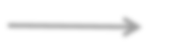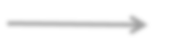

USER

REGISTRATION

LOGIN

LOGIN

ADD PRODUCT TO A CART

BUY A PRODUCT

REGISTRATION

**ADMIN FLOW CHART**



ADMIN

LOGIN

SEE ALL THE REVIEWS

***IF NOT REAL THEN***

***DELETE***

**DATABASE**

**ADMIN TABLE:**

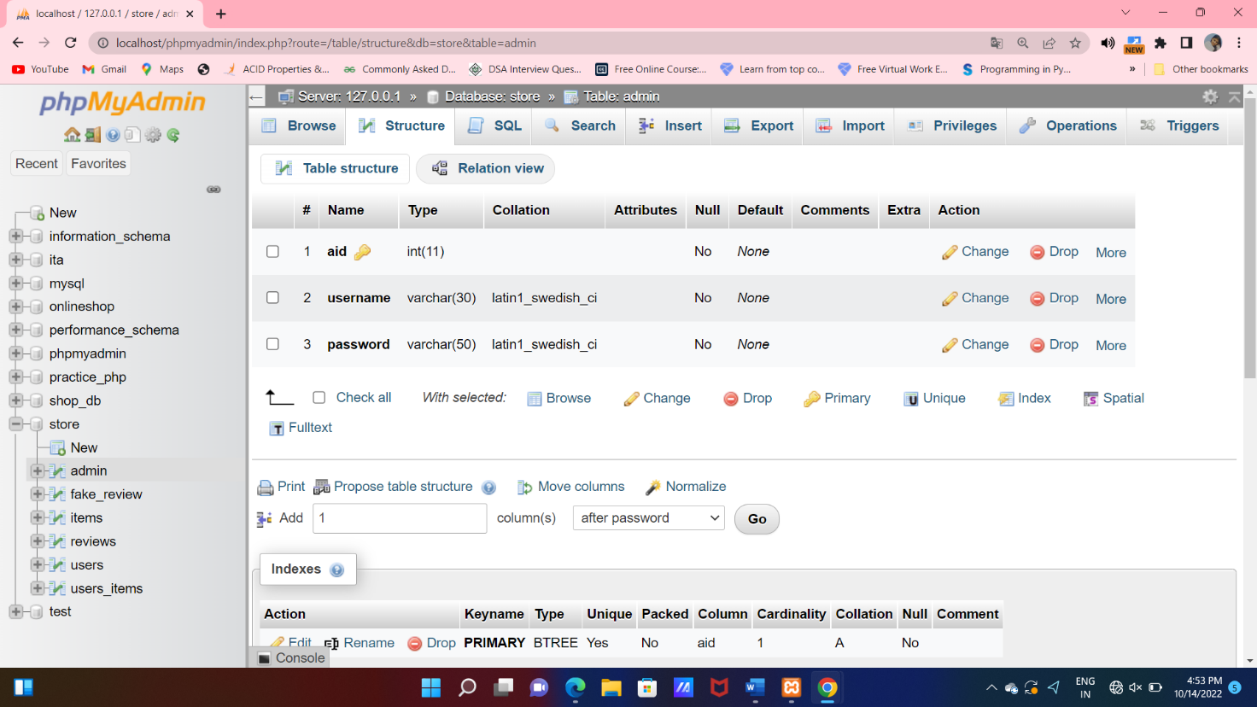

**Table structure for table `admin`**

CREATE TABLE `admin`

(

  `aid` int(11) NOT NULL,

  `username` varchar(30) NOT NULL,

  `password` varchar(50) NOT NULL

);

**Dumping data for table `admin`**

INSERT INTO `admin` (`aid`, `username`, `password`) VALUES

(1, 'admin', 'admin123');

**PRODUCTS TABLE:**

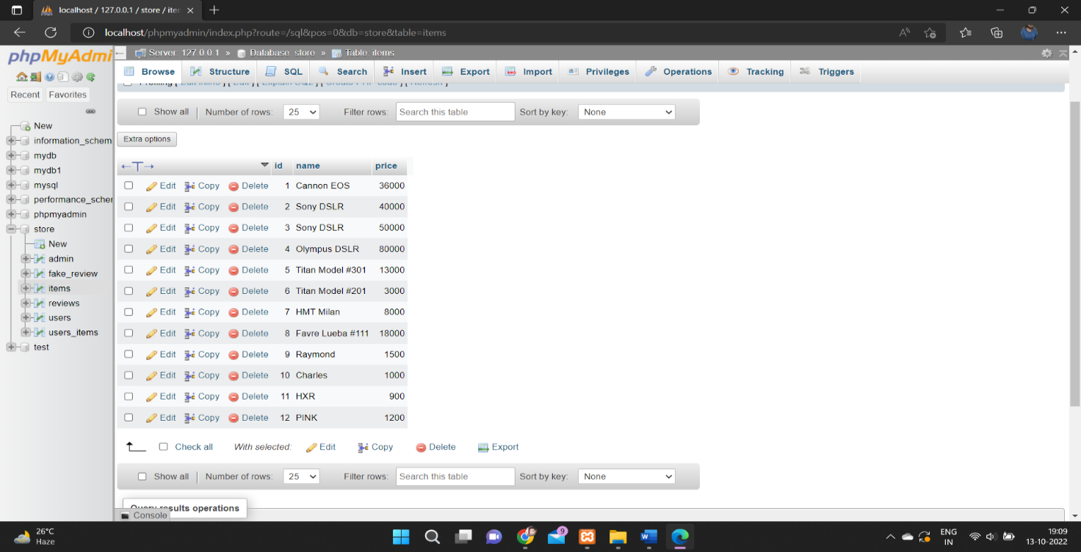

**Table structure for table `items`**

CREATE TABLE `items`

(

  `id` int(11) NOT NULL,

  `name` varchar(255) NOT NULL,

  `price` int(11) NOT NULL

);

**Dumping data for table `items`**

INSERT INTO `items` (`id`, `name`, `price`) VALUES

(1, 'Cannon EOS', 36000),

(2, 'Sony DSLR', 40000),

(3, 'Sony DSLR', 50000),

(4, 'Olympus DSLR', 80000),

(5, 'Titan Model #301', 13000),

(6, 'Titan Model #201', 3000),

(7, 'HMT Milan', 8000),

(8, 'Favre Lueba #111', 18000),

(9, 'Raymond', 1500),

(10, 'Charles', 1000),

(11, 'HXR', 900),

(12, 'PINK', 1200);

**USER TABLE:**

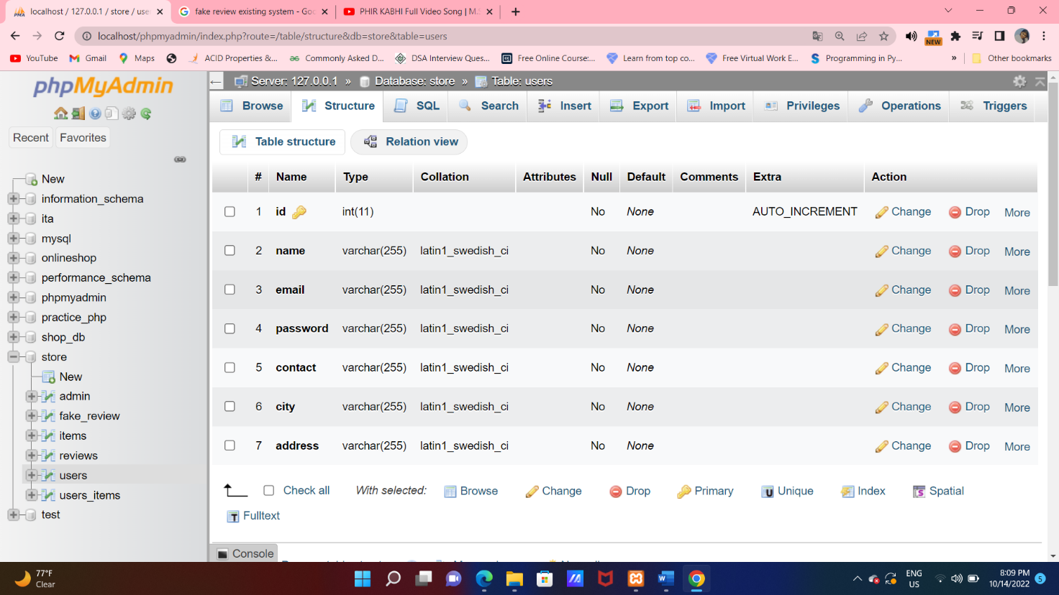

**Table structure for table `users`**

CREATE TABLE `users` (

  `id` int(11) NOT NULL,

  `name` varchar(255) NOT NULL,

  `email` varchar(255) NOT NULL,

  `password` varchar(255) NOT NULL,

  `contact` varchar(255) NOT NULL,

  `city` varchar(255) NOT NULL,

  `address` varchar(255) NOT NULL

);

**Dumping data for table `users`**

INSERT INTO `users` (`id`, `name`, `email`, `password`, `contact`, `city`, `address`) VALUES

(6, 'Bharti', 'bhartichahal3106@gmail.com', 'b291228a5863a2d1df5455fec52b7f54', '123456789', 'Amritsar', 'kot khalsa');

**REVIEWS TABLE:**

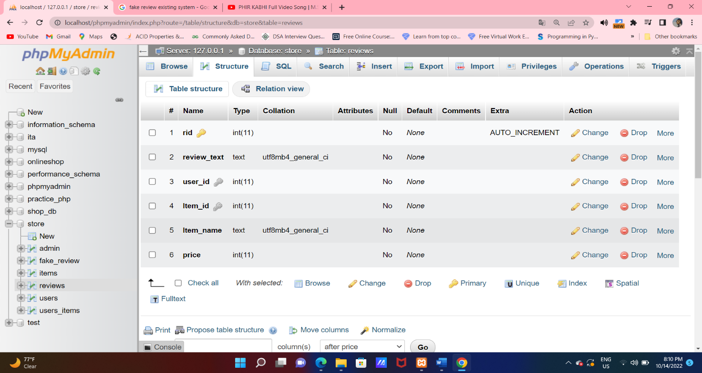

**Table structure for table `reviews`**

CREATE TABLE `reviews`

(

  `rid` int(11) NOT NULL,

  `review_text` text NOT NULL,

  `user_id` int(11) NOT NULL,

  `Item_id` int(11) NOT NULL,

  `Item_name` text NOT NULL,

  `price` int(11) NOT NULL

);

**Dumping data for table `reviews`**

INSERT INTO `reviews` (`rid`, `review_text`, `user_id`, `Item_id`, `Item_name`, `price`) VALUES

(6, 'very good ', 6, 7, 'HMT Milan', 8000),

(8, 'good ', 6, 10, 'Charles', 1000);

**USER’S PRODUCT:**

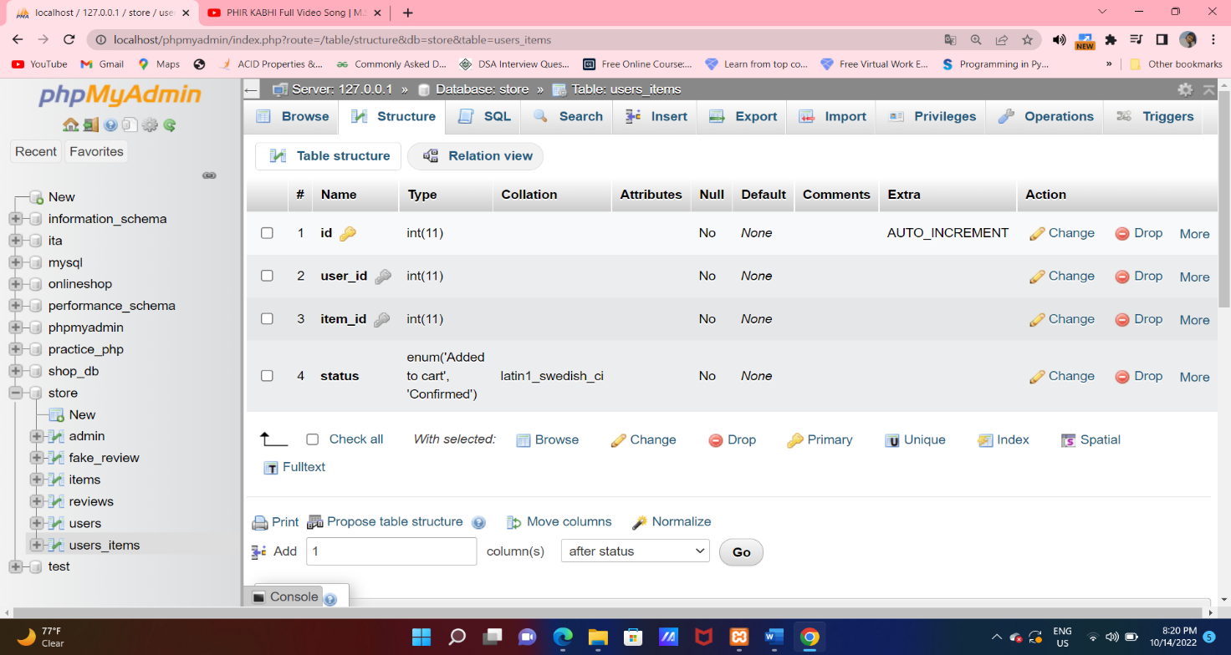

**Table structure for table `users_items`**

CREATE TABLE `users_items`

(

  `id` int(11) NOT NULL,

  `user_id` int(11) NOT NULL,

  `item_id` int(11) NOT NULL,

  `status` enum('Added to cart','Confirmed') NOT NULL

);

**Dumping data for table `users_items`**

INSERT INTO `users_items` (`id`, `user_id`, `item_id`, `status`) VALUES

(26, 6, 0, 'Confirmed'),

(27, 6, 10, 'Confirmed'),

(28, 6, 3, 'Confirmed'),

(29, 6, 4, 'Confirmed'),

(30, 6, 12, 'Confirmed'),

(31, 6, 7, 'Confirmed'),

(32, 6, 7, 'Confirmed'),

(33, 6, 2, 'Confirmed'),

(34, 6, 4, 'Confirmed');

**INTERFACE DESIGN**

**USER REGISTRATION:** User registration systems are screens, forms, or profile pages that request information from a user to create a web-based account or profile. A user registration system generally asks a user to create a username and password, and possibly answer other security questions as well. In this module, user can register their name, email, password, contact number for buying a product. This data will be save in the database after that user will login easily.

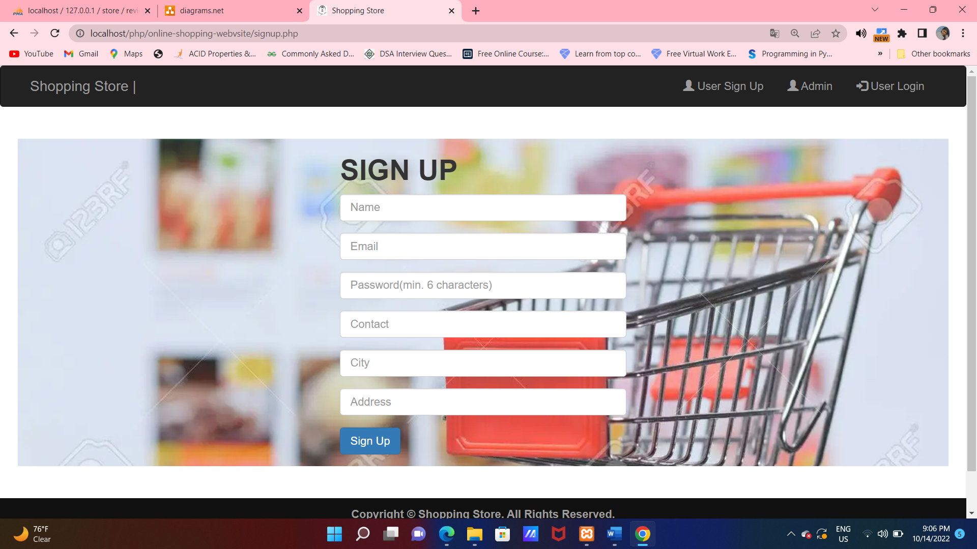

CODE SNIPPETS

<div class="panel-body">

 <p>Login to make a purchase.</p>

 <form method="post" action="admin_submit.php">

 <div class="form-group">

<input type="text" class="form-control" name="usernme" placeholder="Admin Name" >

 </div>

 <div class="form-group">

 <input type="password" class="form-control" name="password" placeholder="Password" pattern=".{6,}"></div>

**User Login:** A login is a set of credentials used to authenticate a user. Most often, these consist of a username and password. Logins are used by websites, computer applications, and mobile apps. They are a security measure designed to prevent unauthorized access to confidential data. It will match the user id and password with the user database table if it matches then it will automatically go to a homepage of the website. Otherwise, it shows that enter the correct.

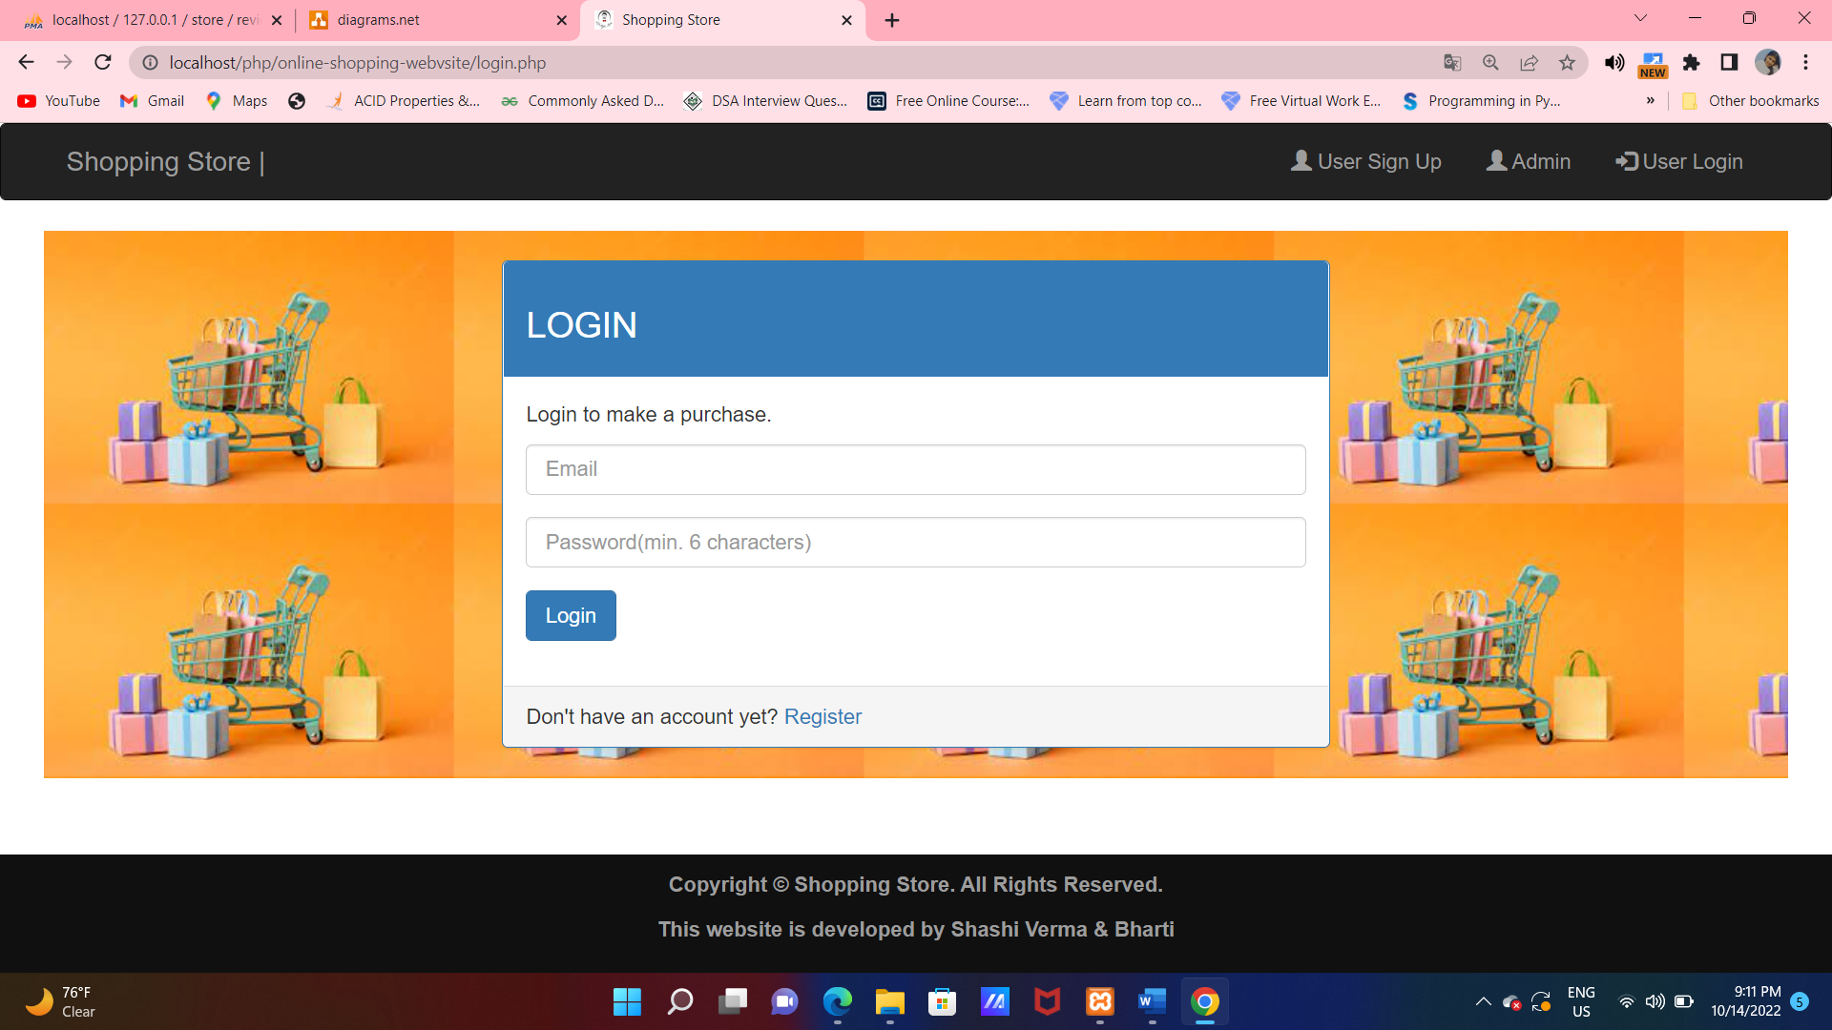

**User Change Password-**: In case, user has forgot their password so, he/she can forgot their password and if they want to change their old password with new he/she can change their password.

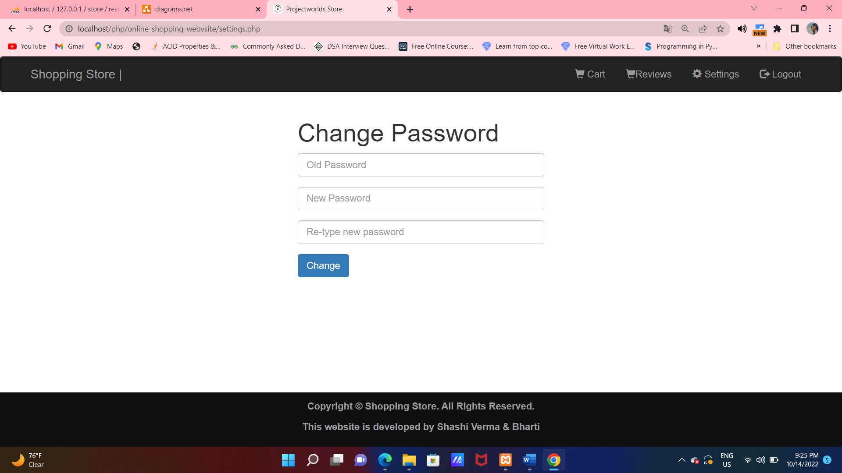

**CODE SNIPPETS:**

$password_from_database_query="select password from users where email='$email'";

    $password_from_database_result=mysqli_query($con,$password_from_database_query) or die(mysqli_error($con));

    $row=mysqli_fetch_array($password_from_database_result);

    //echo $row['password'];

    if($row['password']==$old_password){

        $update_password_query="update users set password='$new_password' where email='$email'";

        $update_password_result=mysqli_query($con,$update_password_query) or die(mysqli_error($con));

        echo "Your password has been updated.";

        ?>

**USER HOME PAGE:** The homepage is a main page where the user can see all the products and also have many options on a header part like add reviews, change password, logout.

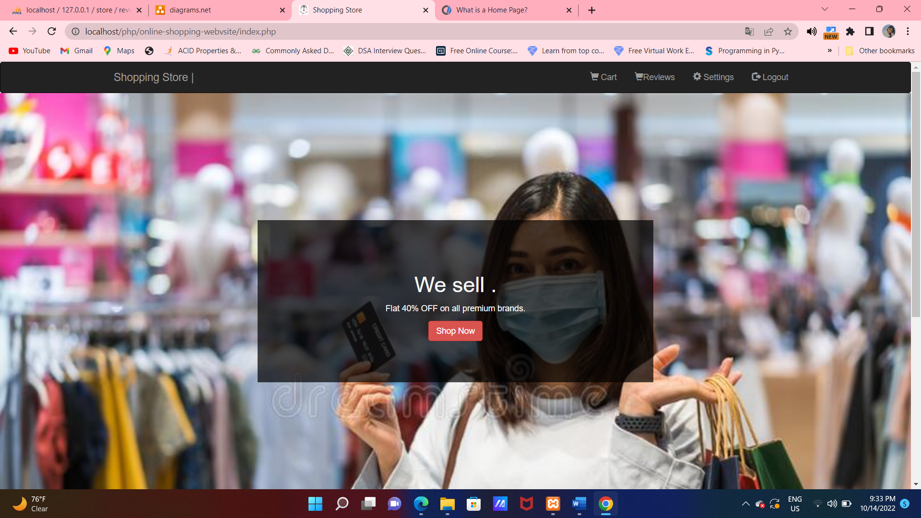

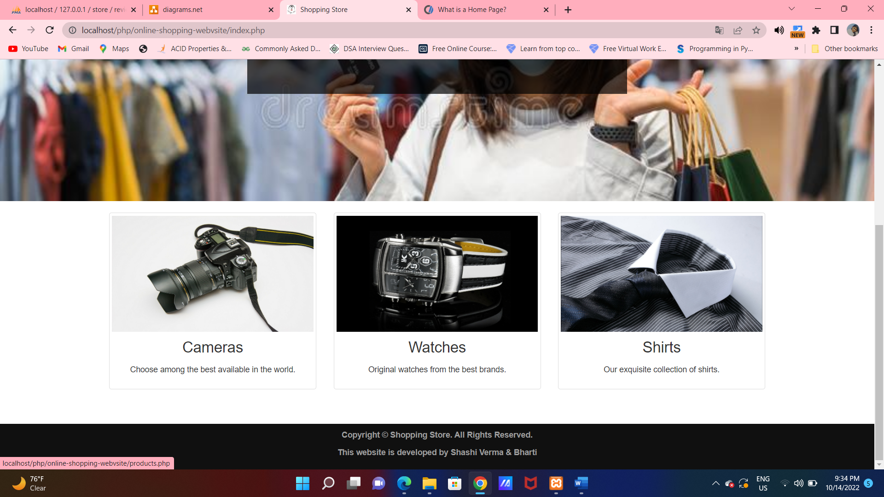

**PRODUCTS PAGE:** The user can click the shop now option from the homepage it shows the products option to the user. The interface for this page is as –

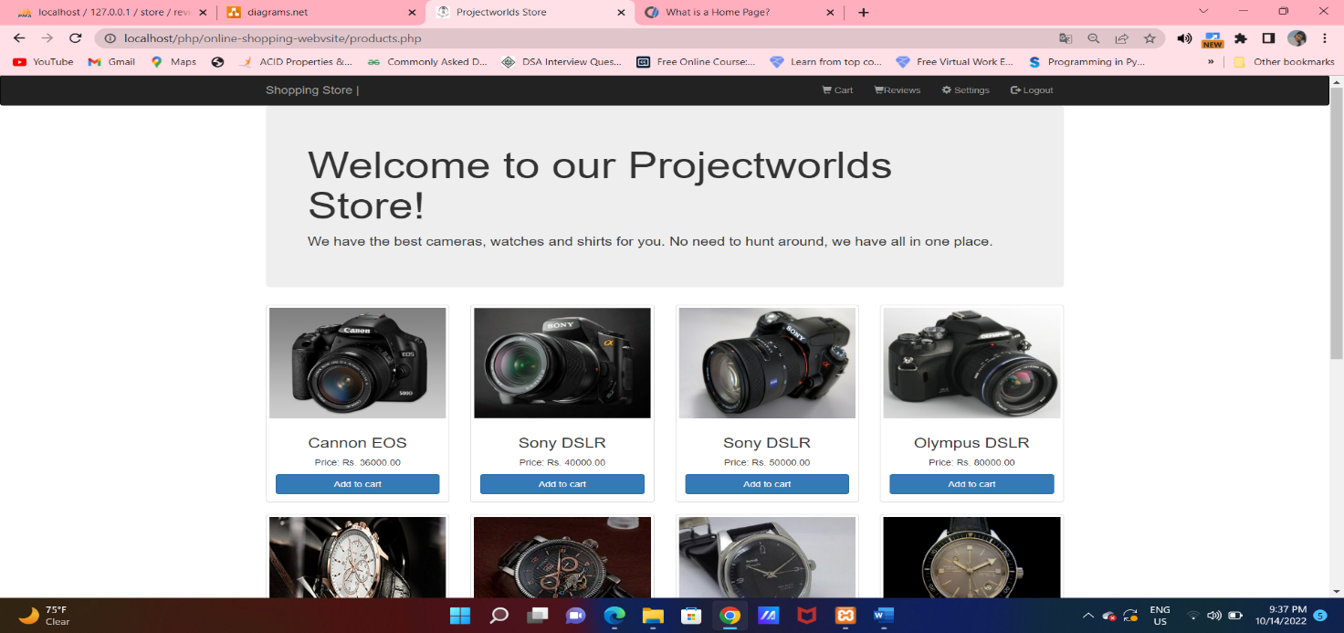

**CODE SNIPPETS:**

 <head>

        <link rel="shortcut icon" href="img/lifestyleStore.png" />

        <title>Projectworlds Store</title>

        <meta charset="UTF-8">

        <meta name="viewport" content="width=device-width, initial-scale=1.0">

        <!-- latest compiled and minified CSS -->

        <link rel="stylesheet" href="bootstrap/css/bootstrap.min.css" type="text/css">

        <!-- jquery library -->

        <script type="text/javascript" src="bootstrap/js/jquery-3.2.1.min.js"></script>

        <!-- Latest compiled and minified javascript -->

        <script type="text/javascript" src="bootstrap/js/bootstrap.min.js"></script>

        <!-- External CSS -->

        <link rel="stylesheet" href="css/style.css" type="text/css">

    </head>

**Cart Page**: The user can add a product into a cart which he wants to buy and after that there is an option CONFRIM ORDER for buy a product.

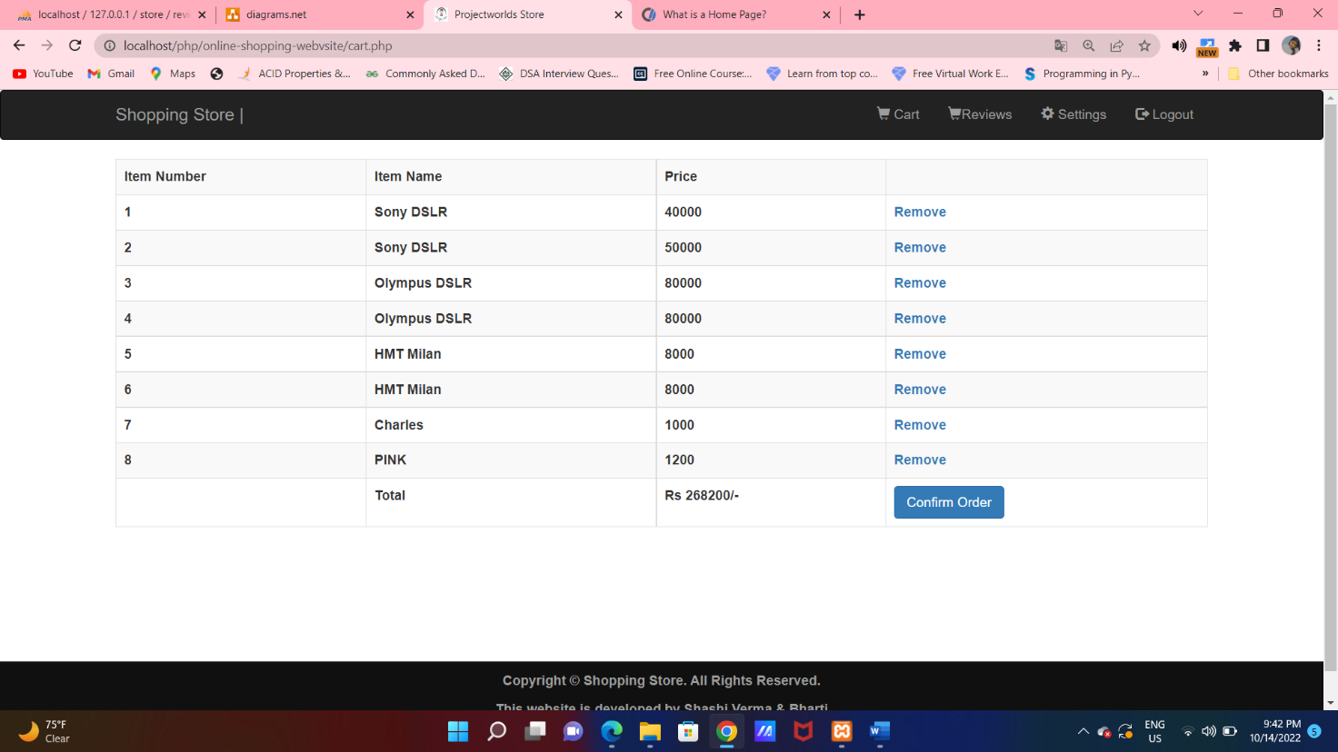

**CODE SNIPPETS:**

<?php

                        $user_products_result=mysqli_query($con,$user_products_query) or die(mysqli_error($con));

                        $no_of_user_products= mysqli_num_rows($user_products_result);

                        $counter=1;

                       while($row=mysqli_fetch_array($user_products_result)){

                         ?>

                        <tr>

                            <th><?php echo $counter ?></th><th><?php echo $row['name']?></th><th><?php echo $row['price']?></th>

                            <th><a href='cart_remove.php?id=<?php echo $row['id'] ?>'>Remove</a></th>

                        </tr>

                       <?php $counter=$counter+1;}?>

                        <tr>

**Reviews Page:** A user can also add a review on a buying product. But if the user put the words less than 15 then it will count as a fake review.

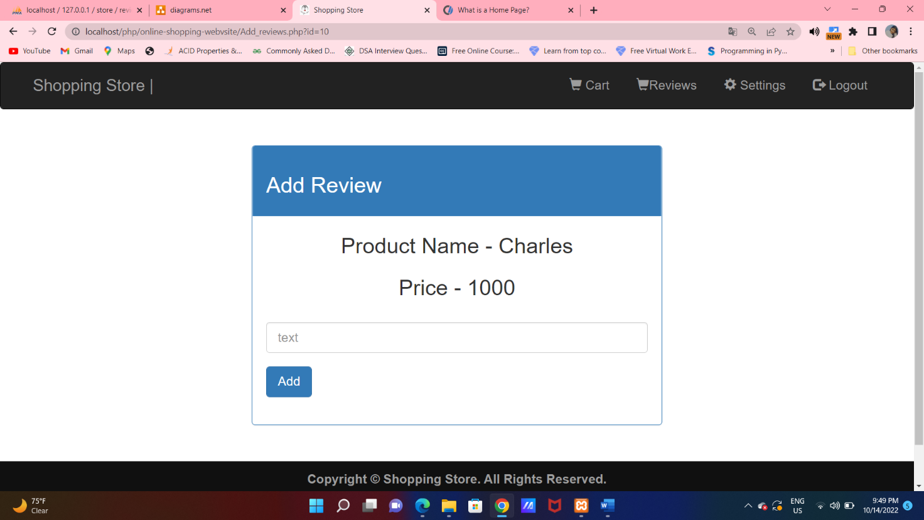

**CODE SNIPPETS:**

<?php

    session_start();

    require 'connection.php';

    if(!isset($_SESSION['email'])){

        header('location: login.php');

    }

    $user_id=$_SESSION['id'];

    $user_products_query="select it.id,it.name,it.price from users_items ut inner join items it on it.id=ut.item_id where ut.user_id='$user_id' and ut.status ='Confirmed' ";

    $user_products_result=mysqli_query($con,$user_products_query) or die(mysqli_error($con));

    $no_of_user_products= mysqli_num_rows($user_products_result);

    $sum=0;

    if($no_of_user_products==0){

    ?>

        <script>

        window.alert("Firstly buy something !!");

        </script>

**After logout:** If the user wants to logout this user id, then it is also possible in our website. The interface after logout is as –

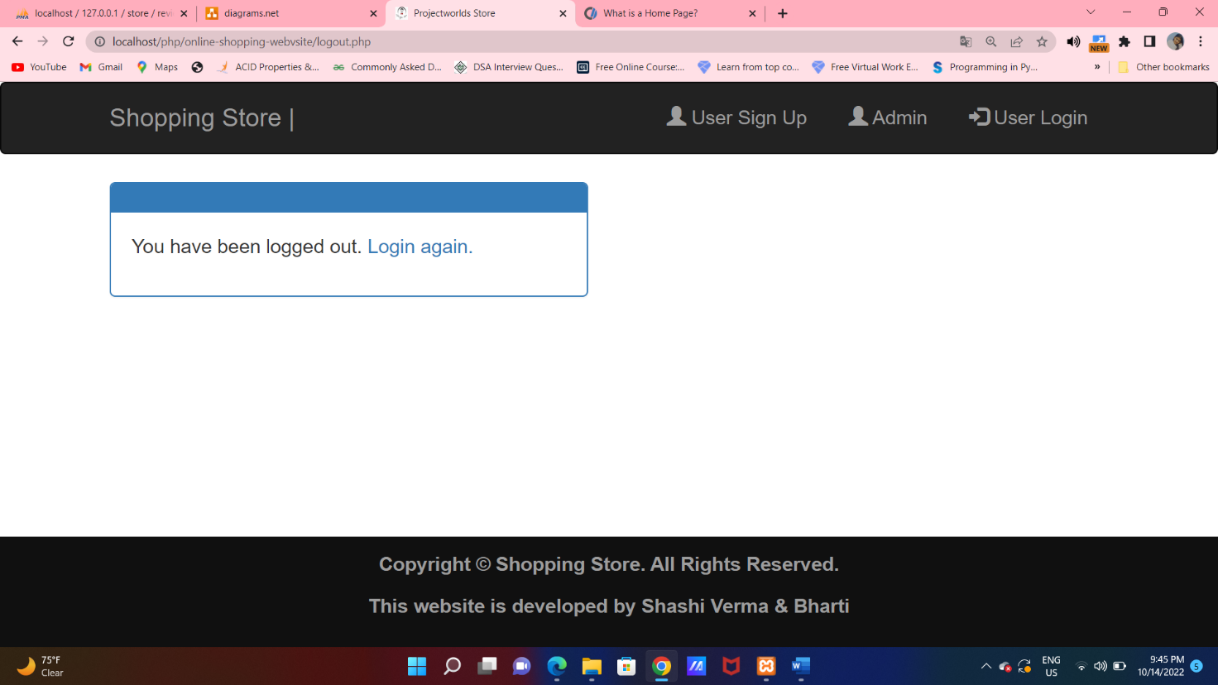

**CODE SNIPPETS:**

<?php

                require 'header.php';

            ?>

            <br>

            <div class="container">

                <div class="row">

                    <div class="col-xs-6">

                        <div class="panel panel-primary">

                            <div class="panel-heading"></div>

                            <div class="panel-body">

                                <p>You have been logged out. <a href="login.php">Login again.</a></p>

                            </div>

                        </div>

                    </div>

                </div>

            </div>

            <footer class="footer">

               <div class="container">

**Admin Login:** Most often, these consist of a username and password. It will match the admin id and password with the admin database table if it matches then it will automatically go to a Admin homepage of the website. Otherwise, it shows that enter the correct.

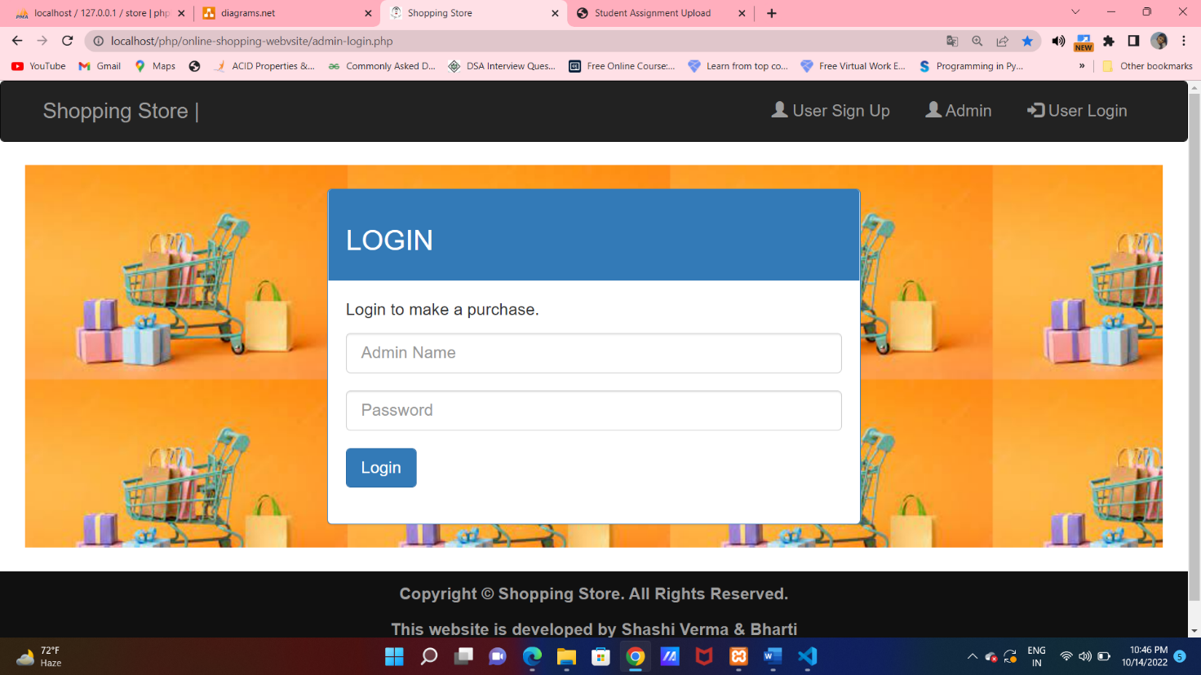

**CODE SNIPPETS:**

 <div class="panel-body">

                                <p>Login to make a purchase.</p>

                                <form method="post" action="admin_submit.php">

                                    <div class="form-group">

                                        <input type="text" class="form-control" name="usernme" placeholder="Admin Name" >

                                    </div>

                                    <div class="form-group">

                                        <input type="password" class="form-control" name="password" placeholder="Password" pattern=".{6,}">

                                    </div>

                                    <div class="form-group">

                                        <input type="submit" value="Login" class="btn btn-primary">

                                    </div>

                                </form>

**ADMIN HOMEPAGE:** Admin can see all the reviews and also delete the reviews.

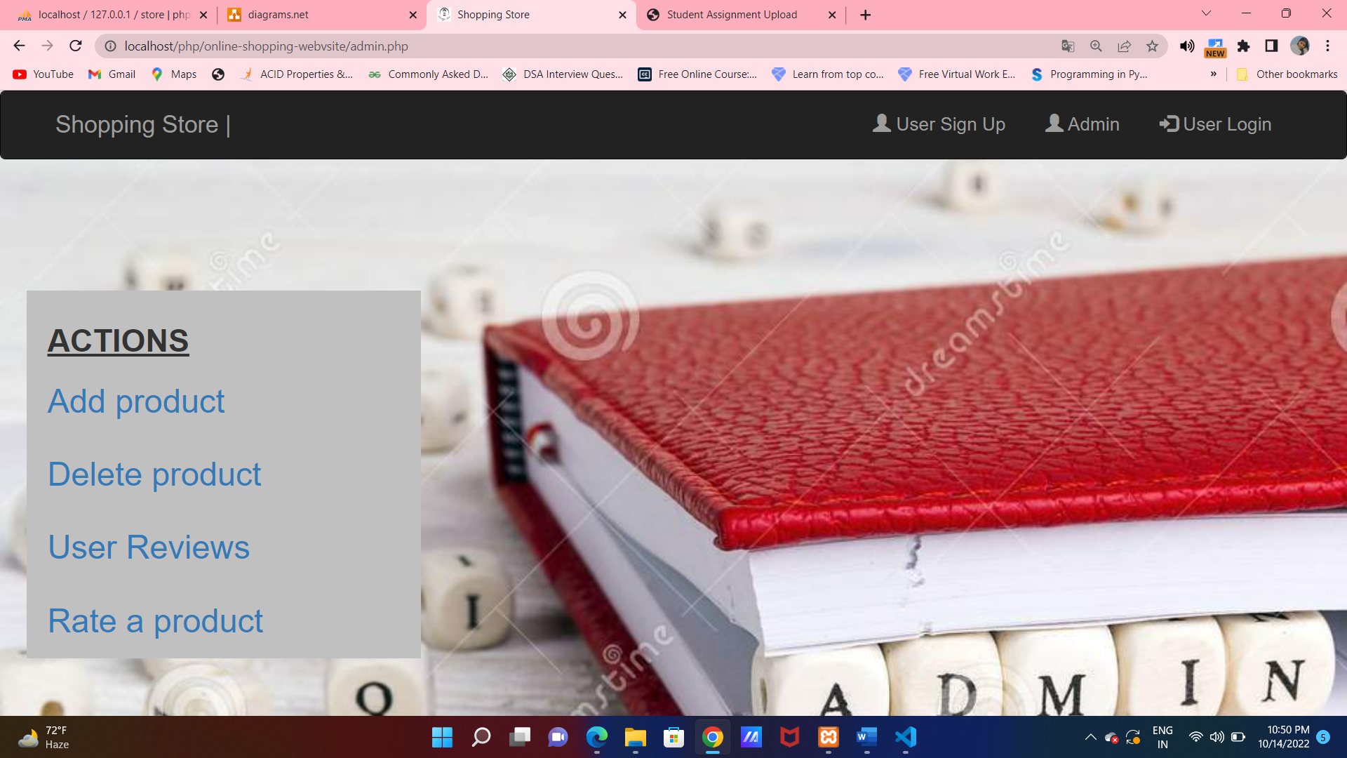

**CODE SNIPPETS:**

.sidenav h3 {

    font-weight: bold;

    font-family: "Lato", sans-serif;

    margin-left: 16px;

    width:200px;

    margin-bottom: 5px;

}</style>

</head>

<body>

<div class="sidenav">

  <h3><u>ACTIONS</u></h3>

  <a href="admin-add-product.php">Add product</a>

  <a href="admin-delete-product.php">Delete product</a>

  <!--<a href="admin-show-review.php">Show reviews</a>-->

  <a href="admin-review-page.php">User Reviews</a>

  <a href="admin-rate-product.php">Rate a product</a>

</div>

</body>

**ADMIN REVIEWS PAGE:** Admin get an option to see all reviews and fake reviews common reviews.

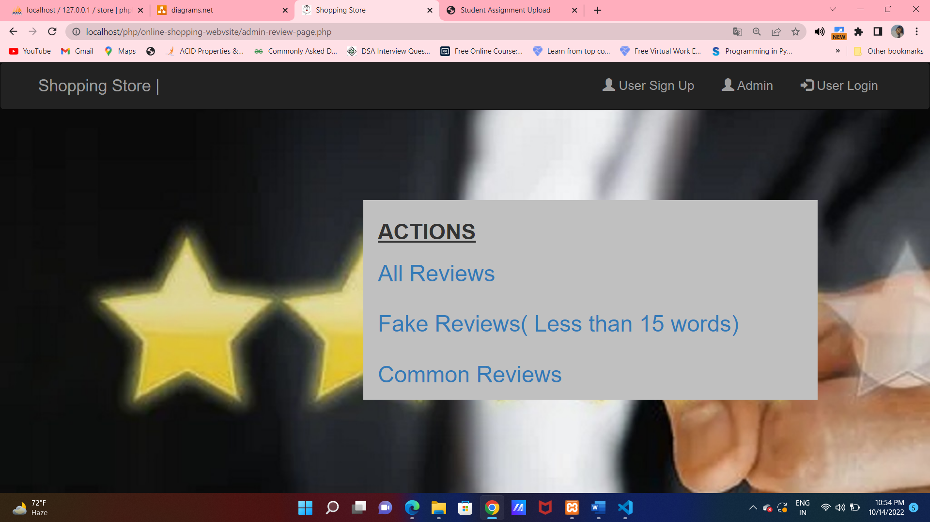

**CODE SNIPPETS:**

.sidenav h3 {

    font-weight: bold;

    font-family: "Lato", sans-serif;

    margin-left: 16px;

    width:200px;

    margin-bottom: 5px;

}

</head>

<body>

<div class="sidenav">

  <h3><u>ACTIONS</u></h3>

  <a href="admin-review.php">All Reviews</a>

  <a href="15-less-review.php">Fake Reviews( Less than 15 words)</a>

  <a href="common-reviews.php">Common Reviews</a>

</div>

</body>

</html>

</div>

**ALL REVIEWS:**

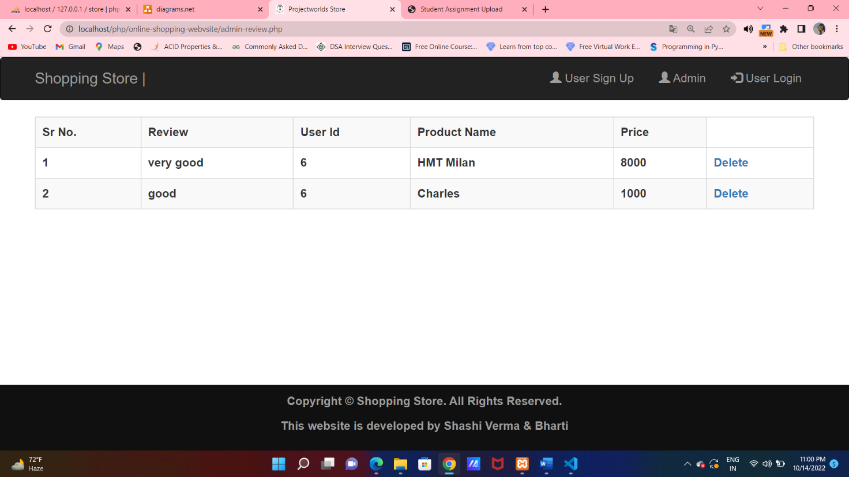

**CODE SNIPPETS:**

 <?php

                        $user_products_result=mysqli_query($con,$user_products_query) or die(mysqli_error($con));

                        $no_of_user_products= mysqli_num_rows($user_products_result);

                        $counter=1;

                       while($row=mysqli_fetch_array($user_products_result)){

                         ?>

                        <tr>

                            <th><?php echo $counter ?></th>

                            <th><?php echo $row['review_text']?></th>

                            <th><?php echo $row['user_id']?></th>

                            <th><?php echo $row['Item_name']?></th>

                            <th><?php echo $row['price']?></th>

                            <th><a href='admin_review_delete.php?rid=<?php echo $row['rid'] ?>'>Delete</a></th>

**FAKE REVIEWS (LESS THAN 15 LETTERS)**

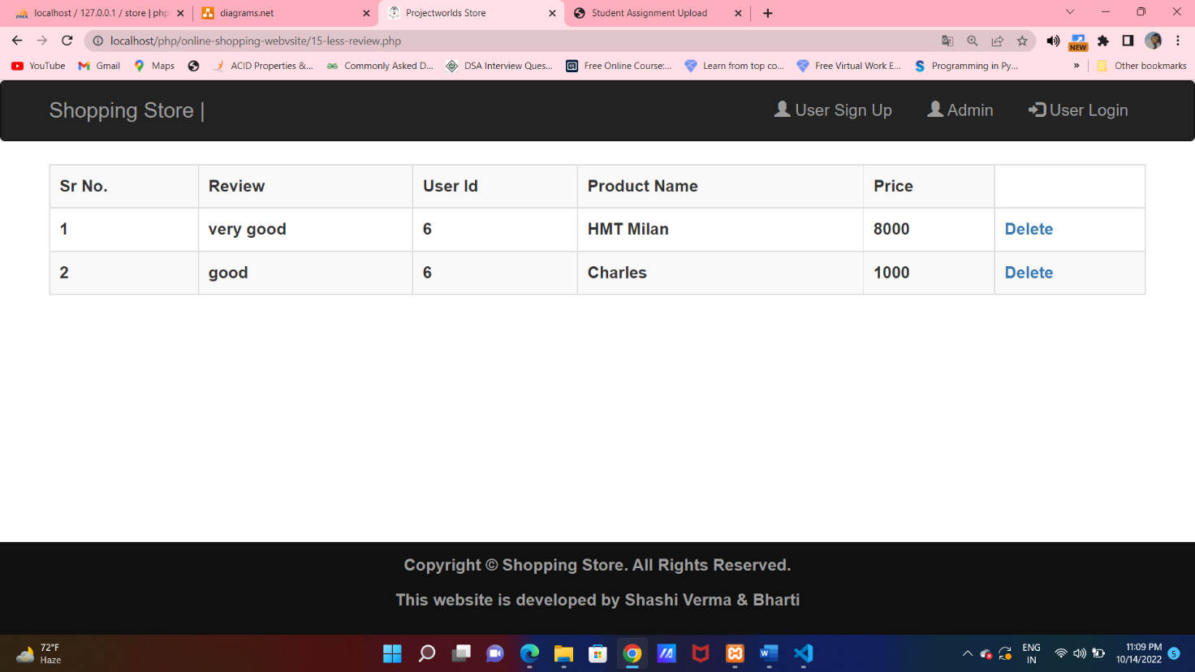

**CODE SNIPPETS:**

<?php

    session_start();

    require 'connection.php';

    $user_products_query="select * from reviews where length(review_text)<15";

    $user_products_result=mysqli_query($con,$user_products_query) or die(mysqli_error($con));

    $no_of_user_products= mysqli_num_rows($user_products_result);

?>

<!DOCTYPE html>

<html>

    <head>

        <link rel="shortcut icon" href="img/lifestyleStore.png" />

        <title>Projectworlds Store</title>

        <meta charset="UTF-8">

        <meta name="viewport" content="width=device-width, initial-scale=1.0">

        <!-- latest compiled and minified CSS -->

        <link rel="stylesheet" href="bootstrap/css/bootstrap.min.css" type="text/css">

        <!-- jquery library -->

**DELETE REVIWES:** Admin can delete a reviews. After that the alert will shows as follows.

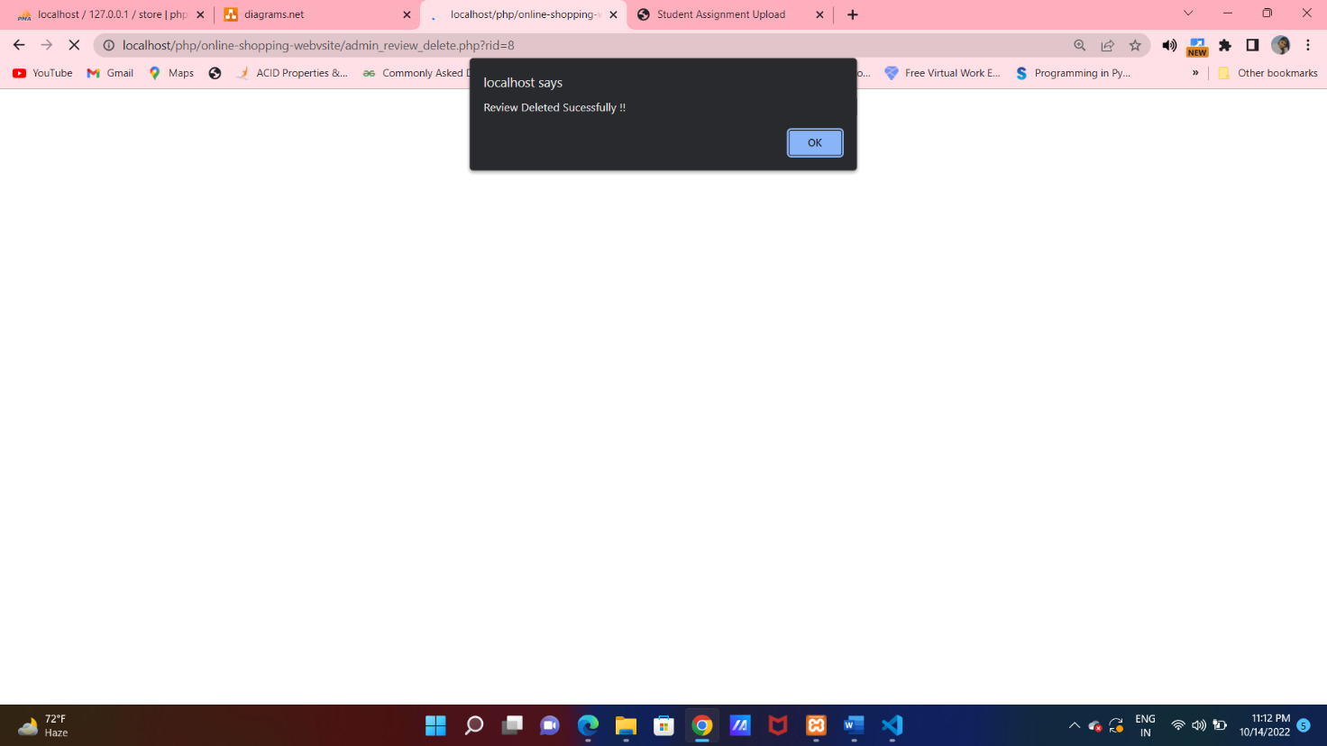

**CODE SNIPPETS:**

<?php

    session_start();

    require 'connection.php';

    $id = $_GET['rid'];

    $user_authentication_query="delete from reviews where rid='$id'";

    $user_authentication_result=mysqli_query($con,$user_authentication_query) or die(mysqli_error($con));

    ?>

    <script>

        window.alert("Review Deleted Sucessfully !!");

        window.location.href='admin-review.php'

    </script>

**SOFTWARE SPECIFICATION**

Software Requirement Specification (SRS) is the starting point of the software developing activity. As system grew more complex it became evident that the goal of the entire system cannot be easily comprehended. Hence the need for the requirement phase arose. The software is initiated by the client needs. The SRS is the means of translating the ideas of the minds of the clients (the i/p) into a formal document (the o/p of the requirement phase). The SRS phase consists of two basic activities:

**Problem or requirement Analysis:** The process is order and more nebulous of the two, deals with understand the problem, the goal and constraints.

**Requirement Specification:** Here, the focus is on specifying what has been found giving analysis such as representation, specification languages and tools, and checking the specifications are addressed during this activity. The requirement phase terminates with the production of the validate SRS document. Producing the SRS document is the basic goal of this phase. The Software Requirements Specification (SRS) begins the translation process that converts the software requirements into the language the developers will use. The SRS draws on the use-cases from the User Requirement Document (URD) and analyzes the situations from a number of perspectives to discover and eliminate inconsistencies, ambiguities, and omissions before development progresses significantly under mistaken assumptions.

**Role of SRS:** The Purpose of the software requirement specification is to reduce the communication gap between the clients and developers. Software requirement specification is the medium, through which the client and user needs are accurately specified. It forms the basis of software development. A good SRS should satisfy all the parties involved in the system.

**CONCLUSION:**

Fake Product Review Monitoring & Removal for Genuine Ratings management

reports in PHP. From our work we have come to a conclusion that finding the

opinion spam from huge amount of unstructured data has become an important

research problem. Although, some of the algorithms have been used in opinion

spam analysis gives good results, but still no algorithm can resolve all the

challenges and difficulties faced by today's generation. It is very important to

consider certain quality measures like helpfulness, usefulness and utility while

analyzing each review. In the literature survey there are many sophisticated

methods explained which defines the sentiment analysis with respect to different

aspects. Our application which will help the user to pay for the right product

without any getting into any scams. You can get report on Fake Product Review

Monitoring & Removal for Genuine Ratings here.

***Some websites referred are:-***

* [*www.google.com*](http://www.google.com/)
* [*www.ZingyHomes.com*](http://www.ZingyHomes.com/)
* *Html/Css/Javascript from w3school.com*
* [*http://www.CodePlanet.com/*](http://www.CodePlanet.com/)
* [*http://jquery.com/*](http://jquery.com/)